TB 6612 Motor Driver – ADAFRUIT

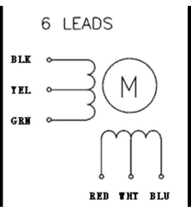

1. Power Pins

Vmotor – connect to battery + terminal (4.5V to 13.5V)

Vcc – connect to 3V on Feather. Voltage for logic levels (i.e. reference). Power the chip.

GND – connect all the grounds together. Shared logic and motor ground.

1. Motor out Pins

Motor A – controlled by INA1, INA2, PWMA

Motor B – same as above but with suffix ‘B’

1. Signal in Pins

INA – inputs to the motor H-bridges

PWMA – PWM input. Connect to HIGH if PWM is unnecessary

STBY – disabling motors. Connect to GND to disable. Pulled up to Vcc through a 10k resistor (built-in I believe).

Channel Configuration

